Guinea-Bissau

## GNI per capita and development level

The data set shows the GNI per capita and development level of the country each year.

## # A tibble: 19 x 5  
## country iso3c date GNIperCapita devCategory   
## <chr> <chr> <dbl> <dbl> <chr>   
## 1 Guinea-Bissau GNB 1996 4753. Upper Middle Income  
## 2 Guinea-Bissau GNB 1998 2988. Lower Middle Income  
## 3 Guinea-Bissau GNB 2000 533. Low Income   
## 4 Guinea-Bissau GNB 2002 521. Low Income   
## 5 Guinea-Bissau GNB 2003 512. Low Income   
## 6 Guinea-Bissau GNB 2004 516. Low Income   
## 7 Guinea-Bissau GNB 2005 526. Low Income   
## 8 Guinea-Bissau GNB 2006 530. Low Income   
## 9 Guinea-Bissau GNB 2007 537. Low Income   
## 10 Guinea-Bissau GNB 2008 534. Low Income   
## 11 Guinea-Bissau GNB 2009 541. Low Income   
## 12 Guinea-Bissau GNB 2010 556. Low Income   
## 13 Guinea-Bissau GNB 2011 591. Low Income   
## 14 Guinea-Bissau GNB 2012 566. Low Income   
## 15 Guinea-Bissau GNB 2013 555. Low Income   
## 16 Guinea-Bissau GNB 2014 576. Low Income   
## 17 Guinea-Bissau GNB 2015 591. Low Income   
## 18 Guinea-Bissau GNB 2016 612. Low Income   
## 19 Guinea-Bissau GNB 2017 617. Low Income

## GDP growth and economic growth classification

The data set shows the GDP growth and the ecomic growth classification of the country each year.

## # A tibble: 19 x 5  
## country iso3c date GDPannualGrowthRate GDPgrowthCategory4  
## <chr> <chr> <dbl> <dbl> <fct>   
## 1 Guinea-Bissau GNB 1996 11.6 fast growth   
## 2 Guinea-Bissau GNB 1998 -28.1 negative grwoth   
## 3 Guinea-Bissau GNB 2000 5.43 moderate growth   
## 4 Guinea-Bissau GNB 2002 -0.985 negative grwoth   
## 5 Guinea-Bissau GNB 2003 0.569 slow growth   
## 6 Guinea-Bissau GNB 2004 2.76 moderate growth   
## 7 Guinea-Bissau GNB 2005 4.27 moderate growth   
## 8 Guinea-Bissau GNB 2006 2.31 slow growth   
## 9 Guinea-Bissau GNB 2007 3.26 moderate growth   
## 10 Guinea-Bissau GNB 2008 3.20 moderate growth   
## 11 Guinea-Bissau GNB 2009 3.37 moderate growth   
## 12 Guinea-Bissau GNB 2010 4.61 moderate growth   
## 13 Guinea-Bissau GNB 2011 8.08 fast growth   
## 14 Guinea-Bissau GNB 2012 -1.71 negative grwoth   
## 15 Guinea-Bissau GNB 2013 3.26 moderate growth   
## 16 Guinea-Bissau GNB 2014 0.965 slow growth   
## 17 Guinea-Bissau GNB 2015 6.13 fast growth   
## 18 Guinea-Bissau GNB 2016 6.26 fast growth   
## 19 Guinea-Bissau GNB 2017 5.92 fast growth

## Development trend

The plot shows the development trend of the country.

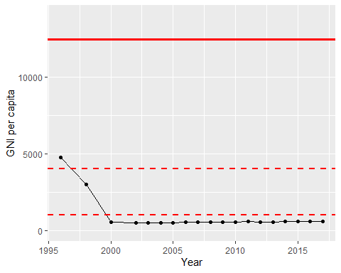

GNI Per Capita Trend